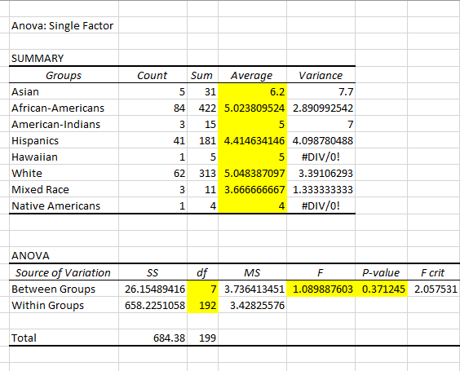

**Knowledge total by ethnical groups**

“A one-way between subjects ANOVA was conducted to compare the effect of Ethnicity on students’ knowledge test results.

There was an insignificant effect of Ethnicity on knowledge test results at the p< .05 level for the three conditions F (1.0899) =3, p=0.37”